|  |  |  |
| --- | --- | --- |
| **Supervisor.** | Sir Aqib | |
| **Batch.** | 7to9-MWF-Prime-202409-G(M) | |
| **Serial No.** | **Student ID** | **Student Name** |
| 1. | Student1604811 | Muhammad Asfar uz zaman khan |
| 2. | Student1585647 | Muzammil ahmed jameel |
| 3. | Student1605183 | Syed Tasbeel Ali |

Marina Fleets

Marina Fleet Website Documentation

Introduction

The Marina Fleet website is a platform for showcasing and selling luxury, sailing, and fishing yachts. It provides users with an interactive gallery, detailed yacht descriptions, and contact forms for inquiries. The website is built using HTML, CSS, JavaScript, and Bootstrap for responsiveness.

## Features

### **1. Responsive Navigation Menu**

* **Hamburger Menu**: Toggles visibility on mobile devices.
* **Dropdown Menu**: Displays yacht categories (Luxury, Sailing, Fishing).

### **2. Image Carousel**

* Displays promotional banners using Bootstrap's carousel component.

### **3. Yacht Listings**

* **Categories**: Luxury, Sailing, and Fishing yachts.
* **Cards**: Each yacht card includes an image, name, price, and "Add to Cart" button.
* **Modals**: Clicking a card opens a modal with detailed yacht information and a PDF download option.

### **4. Image Gallery**

* Displays a grid of images that open in a lightbox modal when clicked.

### **5. Contact Form & Map**

* **Contact Form**: Collects user inquiries (name, email, message).
* **Google Maps**: Embedded map showing the company's location.

### **6. Feedback System**

* Collects user feedback with a rating system and comments.

### **7. PDF Generation**

* Allows users to download yacht details as PDFs using jsPDF.

File Structure

marina-fleet/

├── Images/

│ ├── Logo/

│ ├── About us images/

│ ├── Luxury images/

│ ├── Sailing images/

│ ├── Fishing images/

│ ├── Gallery Images/

│ └── contactUs images/

├── style.css

├── css/

│ └── bootstrap.min.css

└── index.html

Core Functionality

### **1 Navigation Menu**

* **Hamburger Toggle**: Managed by a checkbox (#check) for mobile devices.
* **Dropdown**: Toggles visibility with toggleDropdown().

### **2. Modals**

* **Yacht Details Modal**:
  + Opens with openmodall(modallId).
  + Displays yacht image, description, and a PDF download button.
  + **PDF Generation**: Uses jsPDF to create a PDF with yacht details.
* **Image Gallery Modal**:
  + Opens with openModal(image) to show enlarged images.

### **3. Dynamic Content**

* **Yacht Cards**:
  + Clicking a card opens its modal (excludes "Add to Cart" button).
  + Prices and details are hardcoded in HTML.

### **4. Forms**

* **Contact Form**: Collects name, email, and message.
* **Feedback Form**: Includes a rating dropdown and comments field.

**ACKNOWLEDGEMENT**

The first, we would like to express my special thanks of gratitude to my teacher Sir Aqib, who helped us a lot in finalizing this project within the limited time frame, valuable counseling and assistance for the accomplishment of this project.

Secondly we would also like to thank the eProject team at Aptech Head Office, who gave us the golden opportunity to do this wonderful project about Aura Watch.

Thirdly, we also thank the eProject team, some of the benefits are as under:

* Re-enforcement of skills happens in the experiential learning process.
* A mentor, ensuring that we do not get drifted, constantly guides us.
* It gives us a lot of confidence to face an interview as we have worked on a project. We can explain virtually everything on the subject we have learnt.

SYNOPSIS

Keeping the above in mind and in tune with our constant endeavor to use Technology in our training model, we at Aptech have thought of revolutionizing the way our students learn and implement the concepts using tools themselves by providing a *live and synchronous eProject learning environment!*

PROBLEM DEFINITION

Marina Fleet's website will serve as a comprehensive platform providing detailed information about the various yachts and boats available for rent or purchase. The website will assist customers in selecting the ideal yacht or boat based on their preferences, budget, and specific requirements. It will feature specifications, images, pricing, and availability to ensure a seamless browsing experience. Additionally, the website may include customer reviews, booking options, and special offers to enhance user engagement. By making this information easily accessible, the company can expand its customer base, attract potential buyers or renters, and improve overall customer satisfaction.

CUSTOMER REQUIREMENT SPECIFICATION (CRS)

**Requirement Specification:**

The Web site is to be created based on the following requirements.

* The Home Page should be created making use of Sections with a suitable logo, the header section can be added which will show images yachts and boats
* The site must contain the links to navigate through any category for the information.
* Links of fleets can be categorized like (Luxury, Sailing, Fishing etc.)
* Specification and Pricing of Yacht/Boat can be added along with the images.
* Gallery section can be added for viewing different images.
* Feedback must be allowed to enter by the viewer
* Site map, Gallery, about us, Queries link, Contact us link must be added.
* The complete description must be allowed to get download as pdf or doc file.
* The advertise section with various facilities provided should be mentioned.

SCOPE OF THE WORK (IN BREIF)

The Objective of this program is to give a sample project to work on real life projects. These applications help you build a larger more robust application.

The objective is not to teach you concepts but to provide you with a real life scenario and help you create applications using the tools.

You can revise them before you start with the project.

It is very essential that a student has a clear understanding of the subject.

# AGGREGATED SITEMAP

# Marina fleets

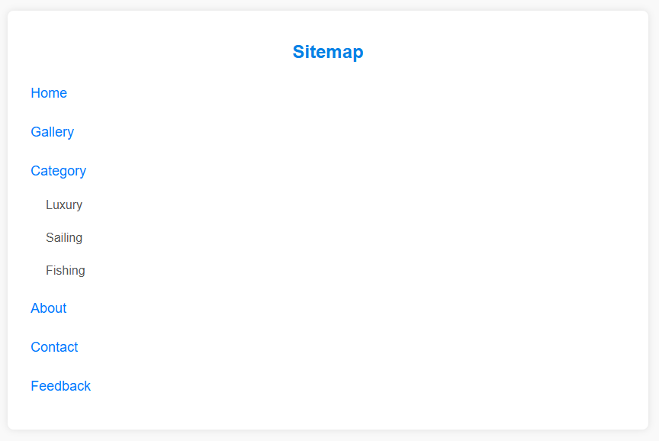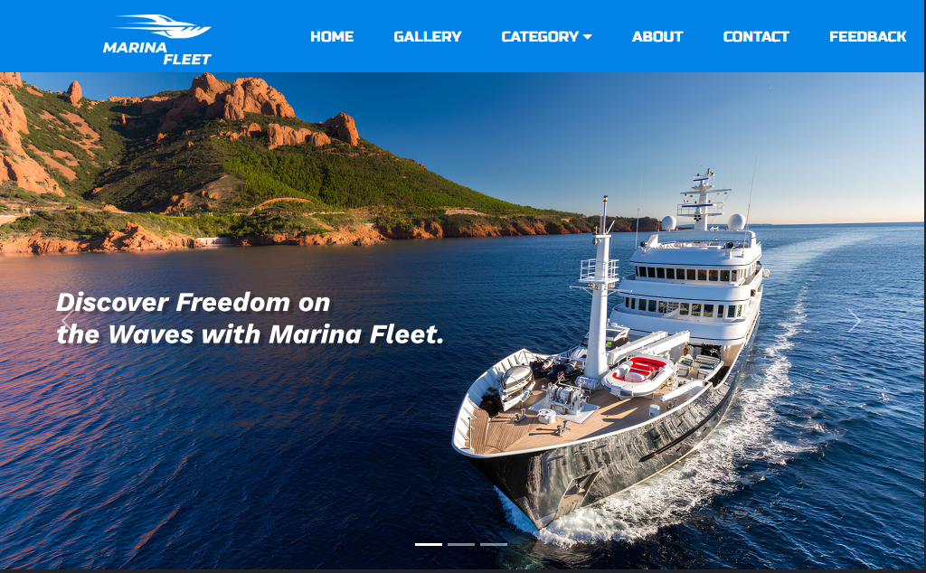

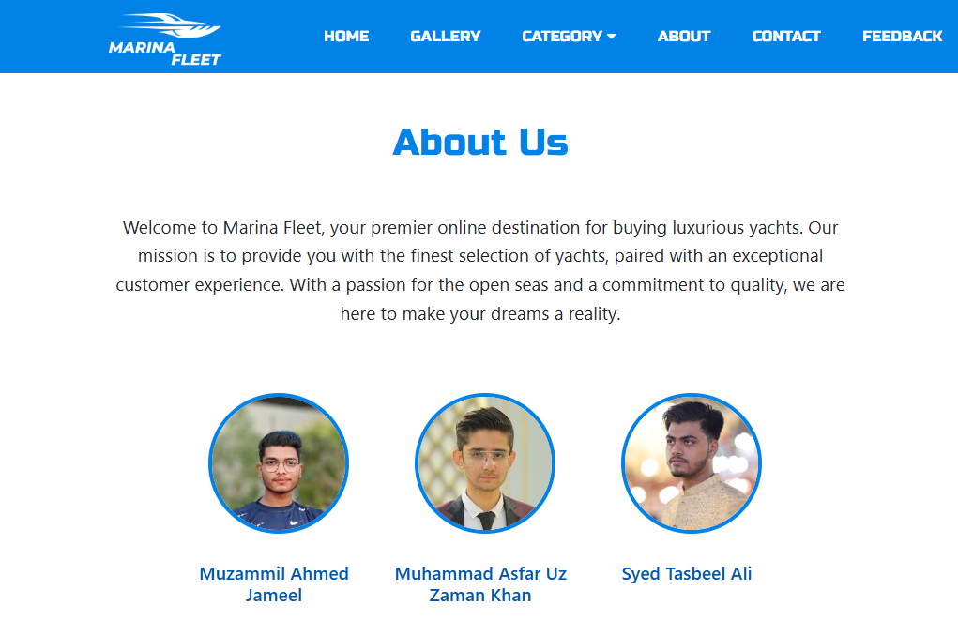

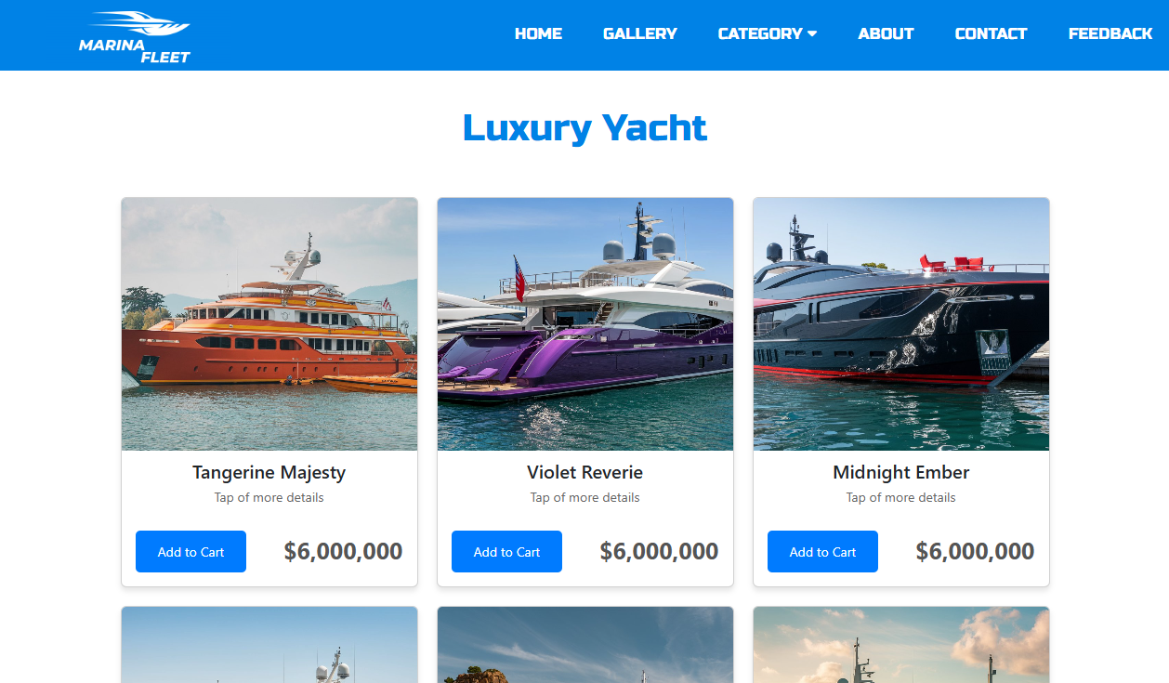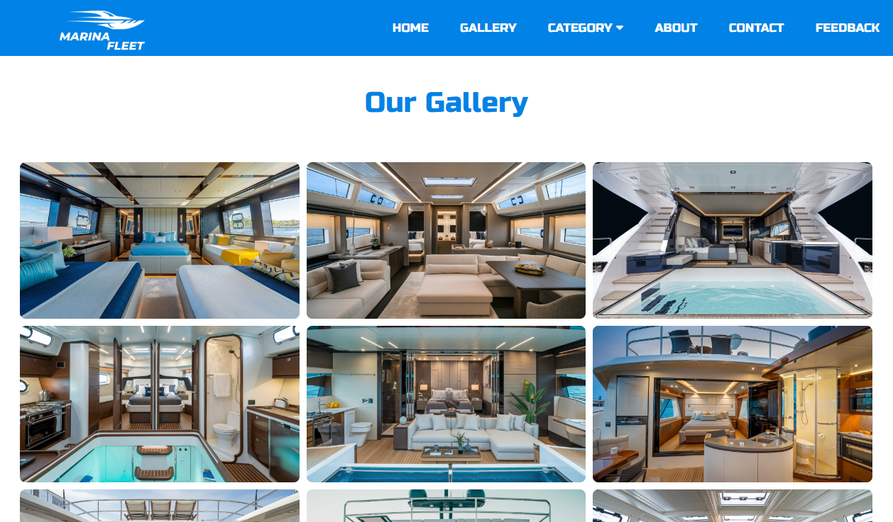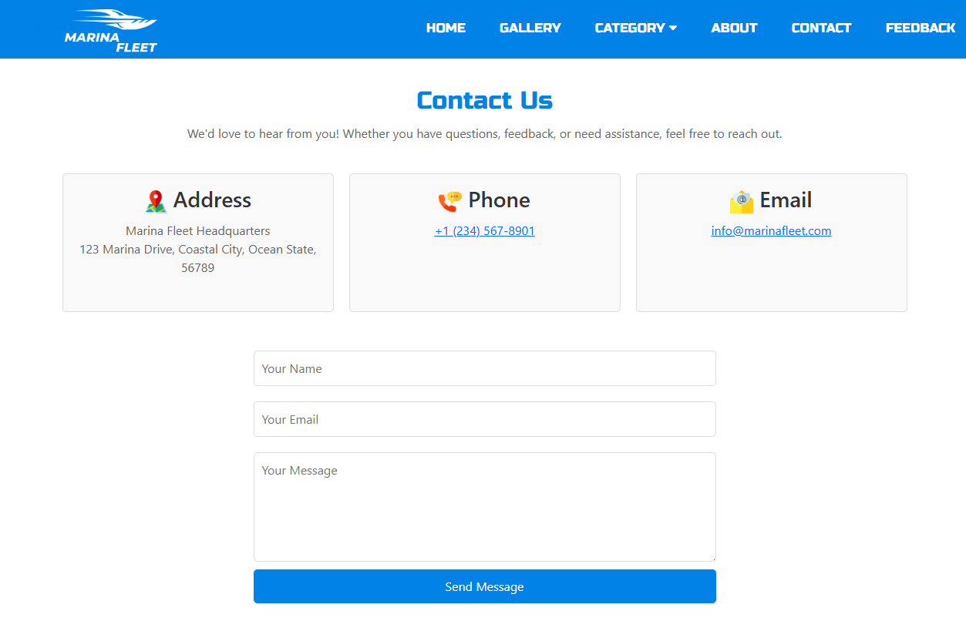

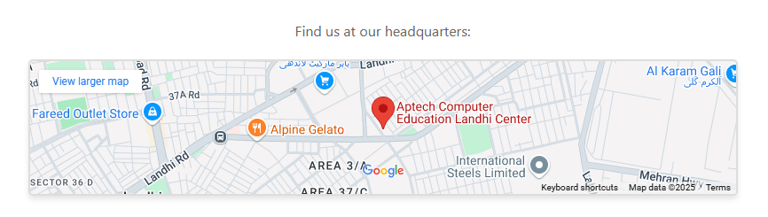

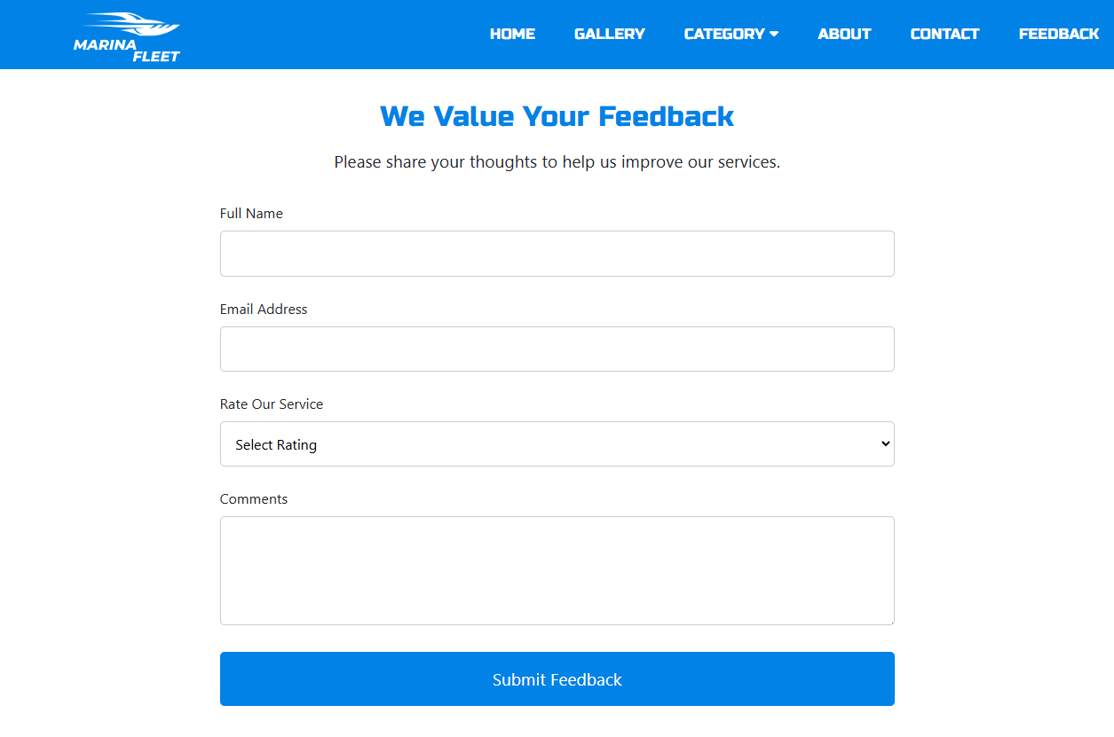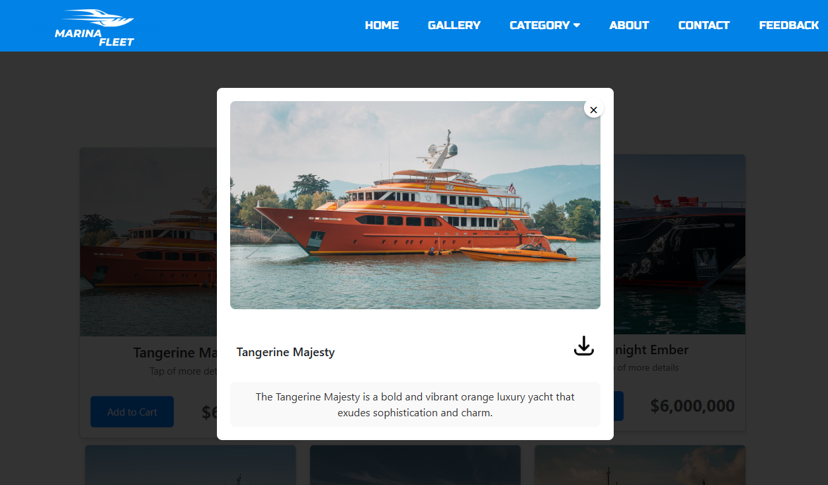

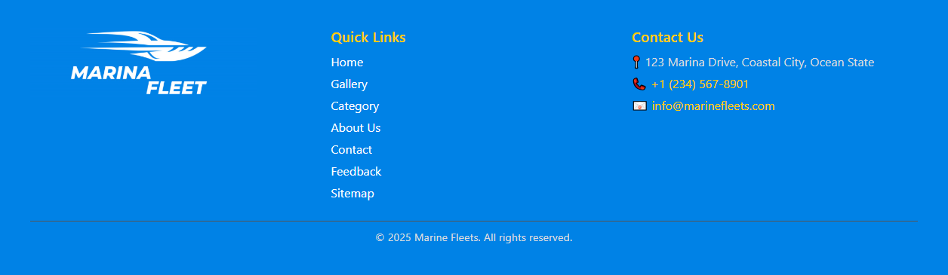

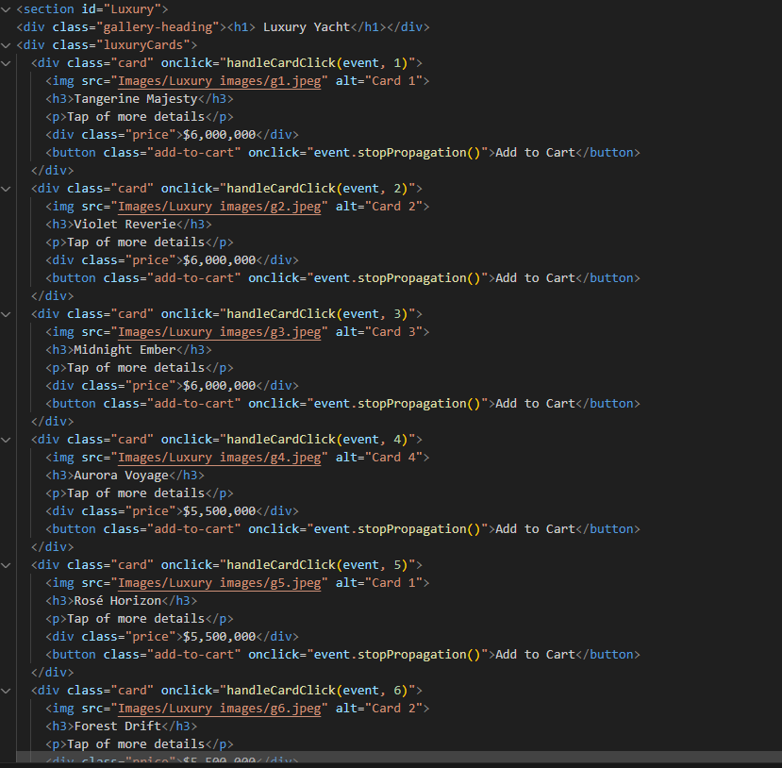

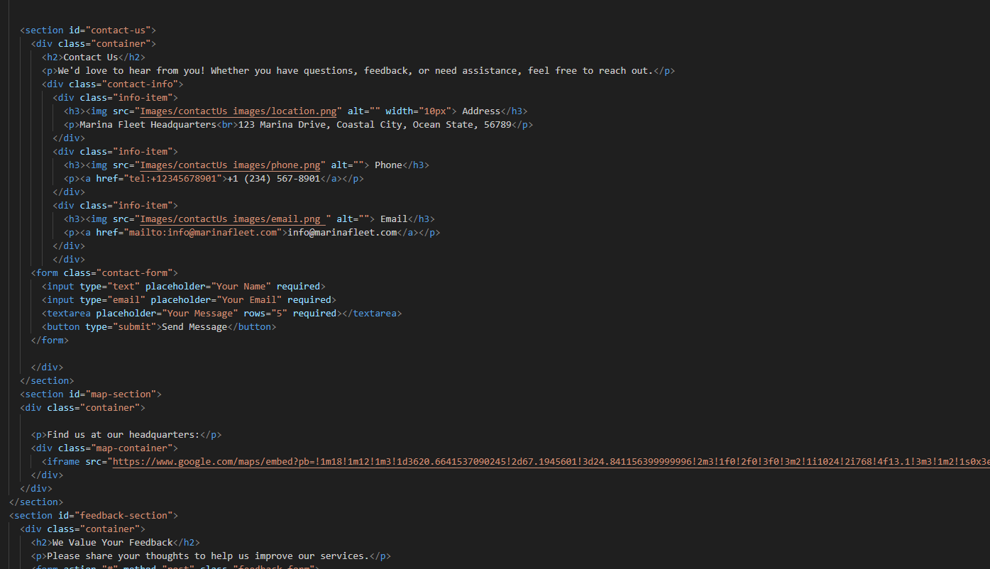

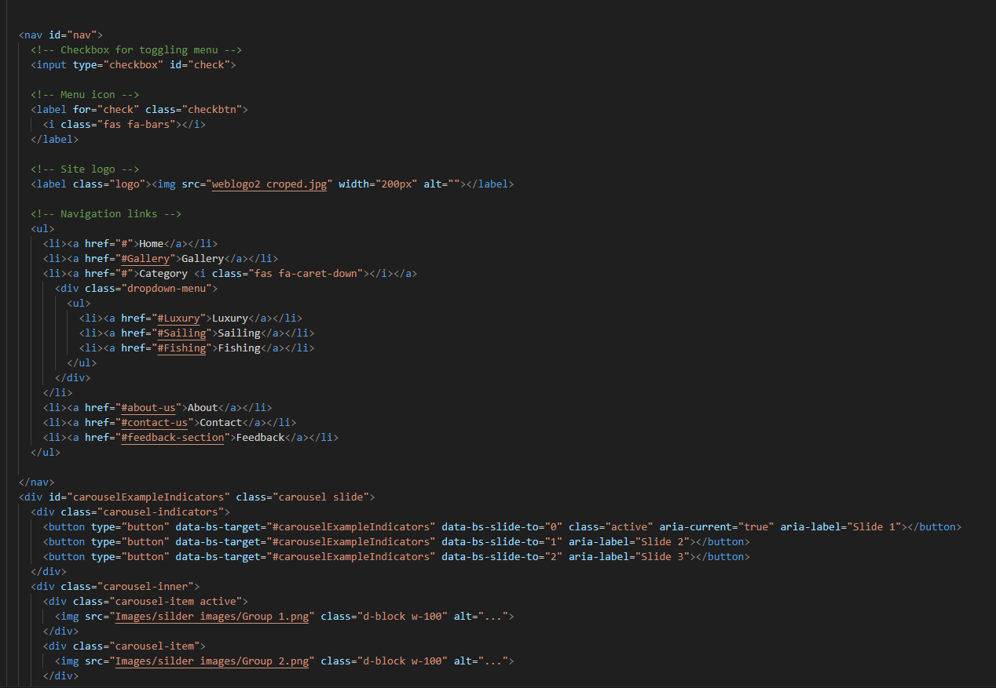

TASK SHEET REVIEW 2

|  |  |  |  |  |  |
| --- | --- | --- | --- | --- | --- |
| **Date:** | **Project Plan/ Milestone** | **Work**  **Specification** | **Status of the Activity** | **Days of work** | **Responsibility** |
| 13/01/2024 | Analysis | Requirements  Paper working/  Project plain | Yes | 3 Days | Asfar, Muzzamil, Tasbeel, |
| 15/01/2025 | UI Screen Design | Complete all website screen | Yes | 3 Days | Asfar |
| 18/01/2024 | Data Collection like (images,  Video, audio) | Data Collect  As per requirement | Yes | 3 Days | Asfar, Muzzamil, Tasbeel, |
| 26/01/2025 | Code  Html,CSS,JAVA | Complete all  Coading | Yes | 8 Days | Asfar, Muzzamil, Tasbeel, |
| 28/01/2025 | Resolve  All issues, images size and all bugs | Complete all | Yes | 2 Days | Asfar |
| 29/01/2025 | Testing | All website testing | Yes | 1 Day | Asfar |

**THANK**

**YOU**